Creating an empty repository in GitHub. Adding collaborators.

If you don't have a GitHub account, sign up by following the instructions.
Creating an online repository in GitHub.
Open the menu next to the "+" (highlighted in red) and select «Create new repository».

Enter a repository name (required), a description (optional), and leave the public/private setting set to "public" (to add collaborators, the repository must be public*). ReadMe, gitignore, license – optional → Create repository
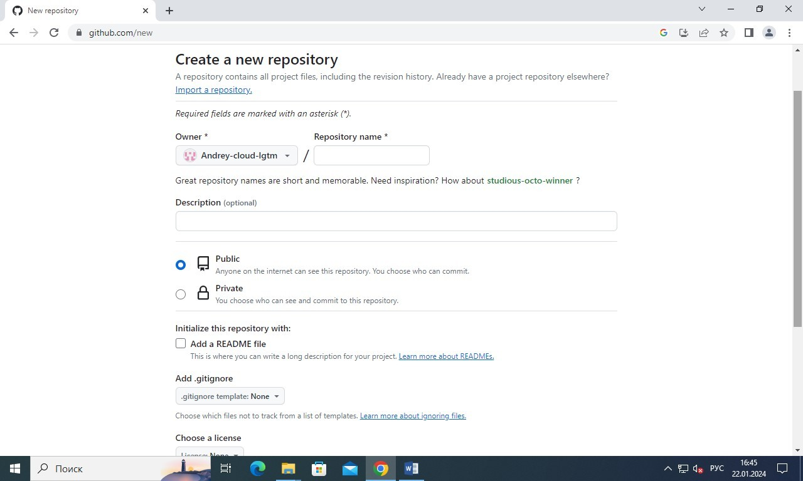

*repositories are classified by visibility as private (available only to the owner) and public (available to all users).

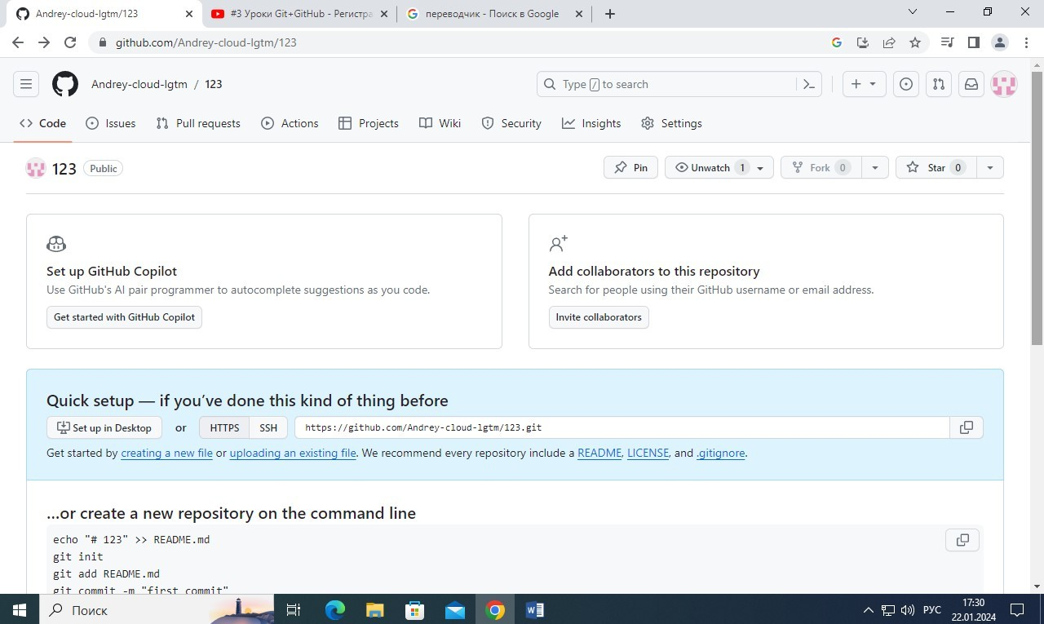
New empty repository:

Adding collaborators (method 1):
On the new repository page: Invite collaborators → Add people → search by username… (enter the name/email of the user you want to add) → Add (the name of the user you want to add) to this repository → Add people (add the next user).
Accept the invitation: click the icon (highlighted in red).
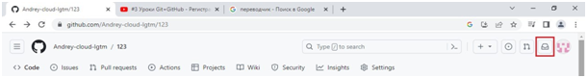
Open the invitation notification (click on it) → Accept the invitation.
You can also accept the invitation via email (the notification is sent to your email address).

Adding collaborators (method 2):
Log in to the repository → Settings → Collaborators → Add people
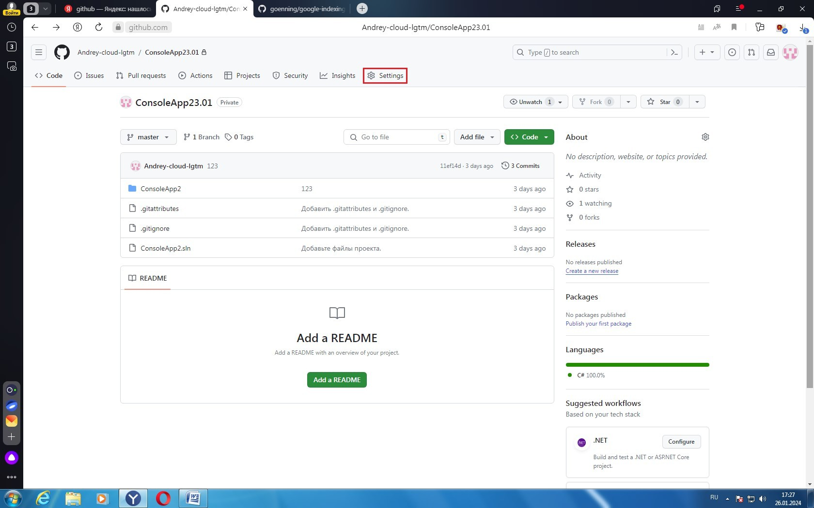

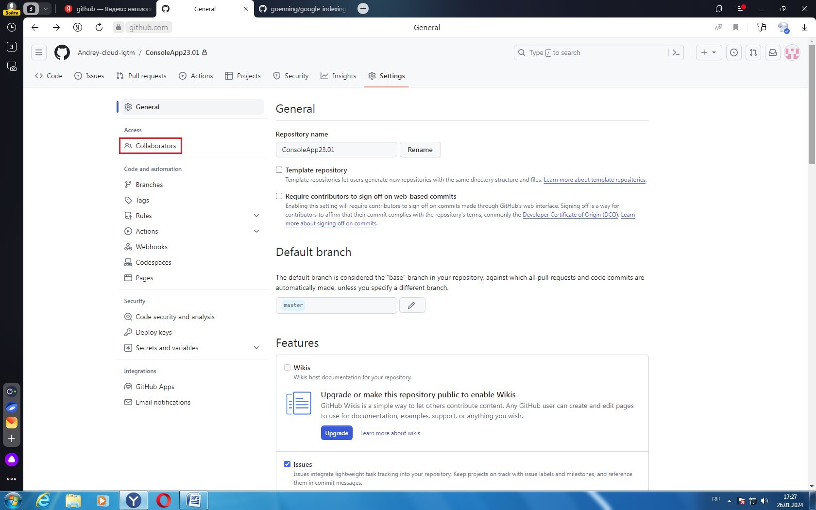

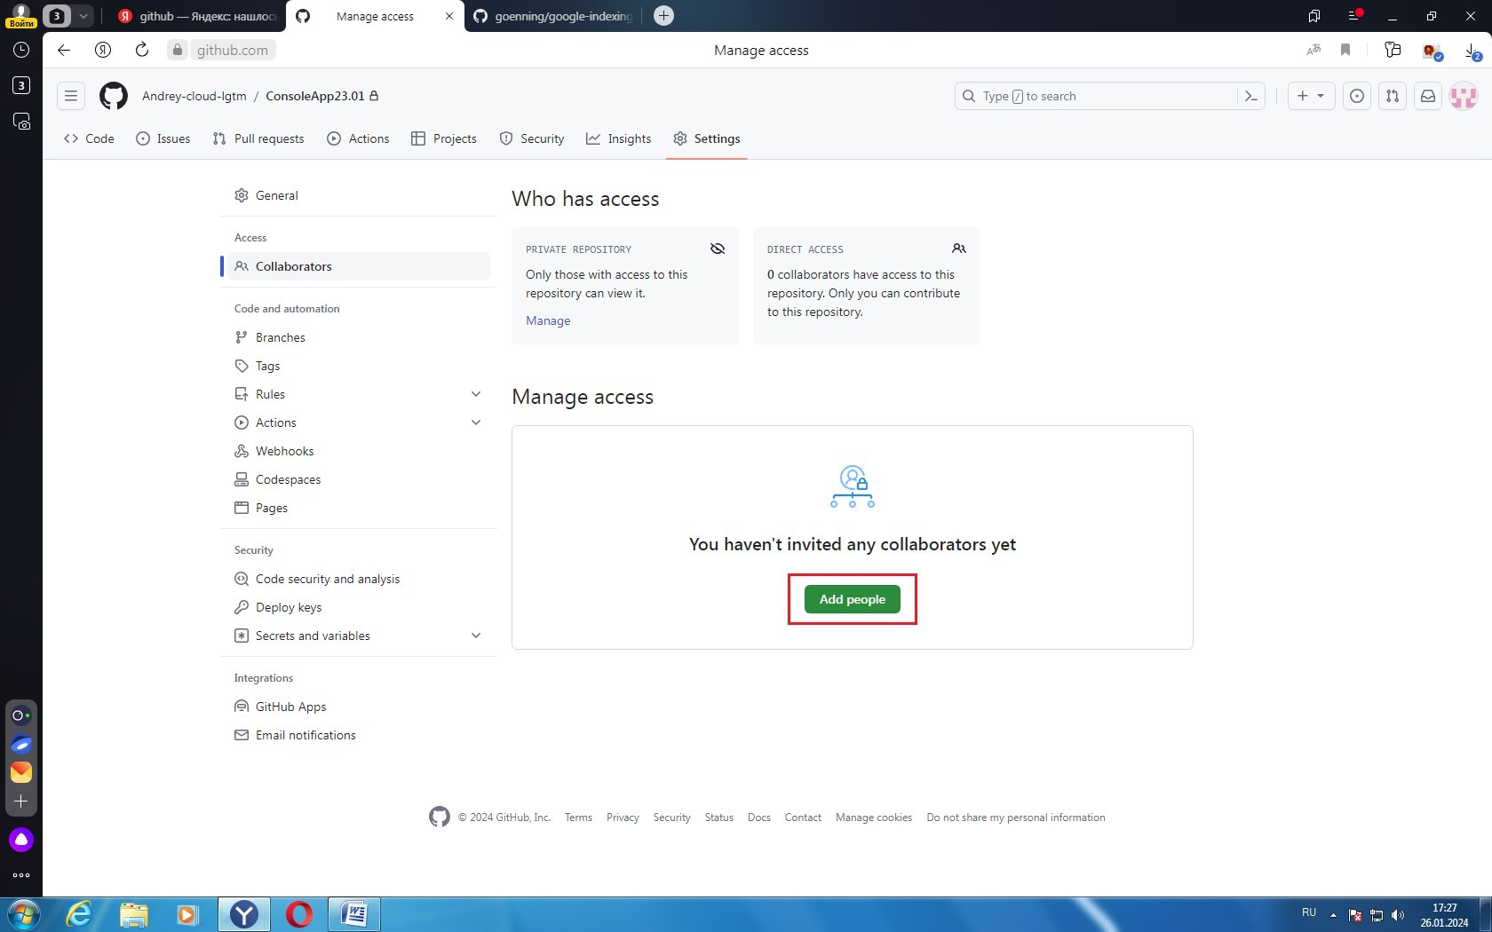
In the window that opens, enter the name/email of the user you want to add → Add.

